21. Find the employee whose commission is Rs. 0.

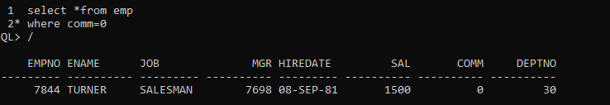

22. Find the different jobs of the employees receiving commission.



23. Find all employees who do not receive a commission or whose Commission is less thanRs. 100.

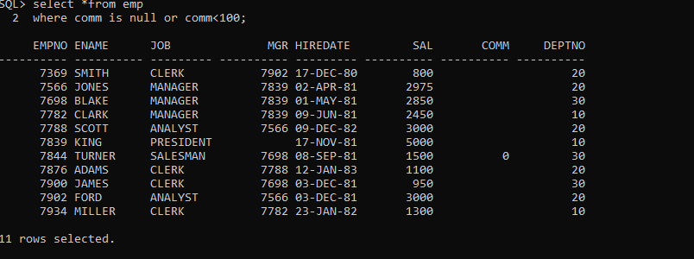

24. The employees who not receiving commission are entailed to Rs. 250, Show the net earnings of all employees. (find about nvl())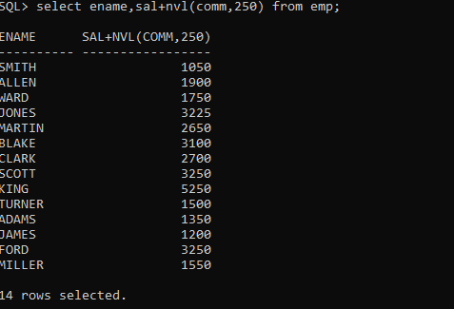

25. Find all employees whose total earnings are greater than Rs. 2000.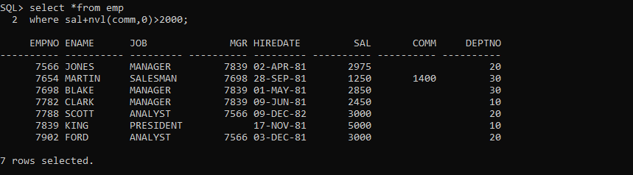

26. Find all employees whose names begin with m.

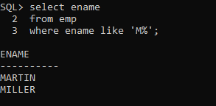

27. Find all employees whose names end with m.

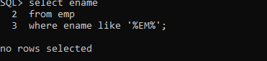

28. Find all employees whose names contain the letter m.

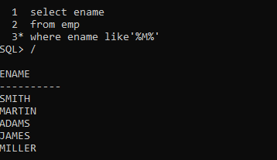

29. Find the employees whose names are 5 characters long and end with n.

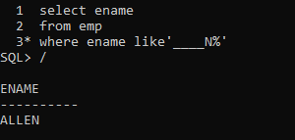

Or

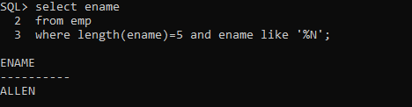

30. Find the employees who have the letter r as the third letter in their name.

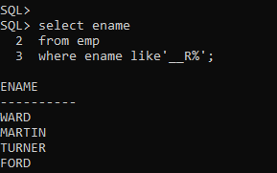

31.Find all employees hired in month of February (of any year).

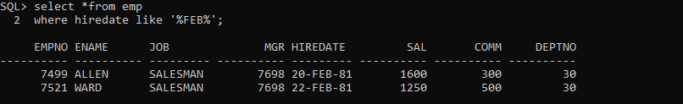

32.Find all employees who were hired on the last day of the month.